# 2. Preparation Exercises

1. Discretization
$H_{CD}(Ω) = ⅇ^{-j\frac{λ_{0}^{2}}{4πc}DLΩ^{2}}$

$H_{CD}\left(Ω\right)=ⅇ^{-j\frac{λ_{0}^{2}}{4πc}DL{\left(\frac{Ω}{F_{s}}F_{s}\right)}^{2} }$

$H_{CD}(ω) = ⅇ^{-j\frac{λ_{0}^{2}}{4πc}DL{\left(ωB\right)}^{2}}$

2. Ideal Equalizer
$G_{Ideal}\left(ω\right)=ⅇ^{j{αω}^{2}}$ $$where α = \frac{λ_{0}^{2}}{4πc}B^{2}DL$$

3. Frequency Sampling
   1. 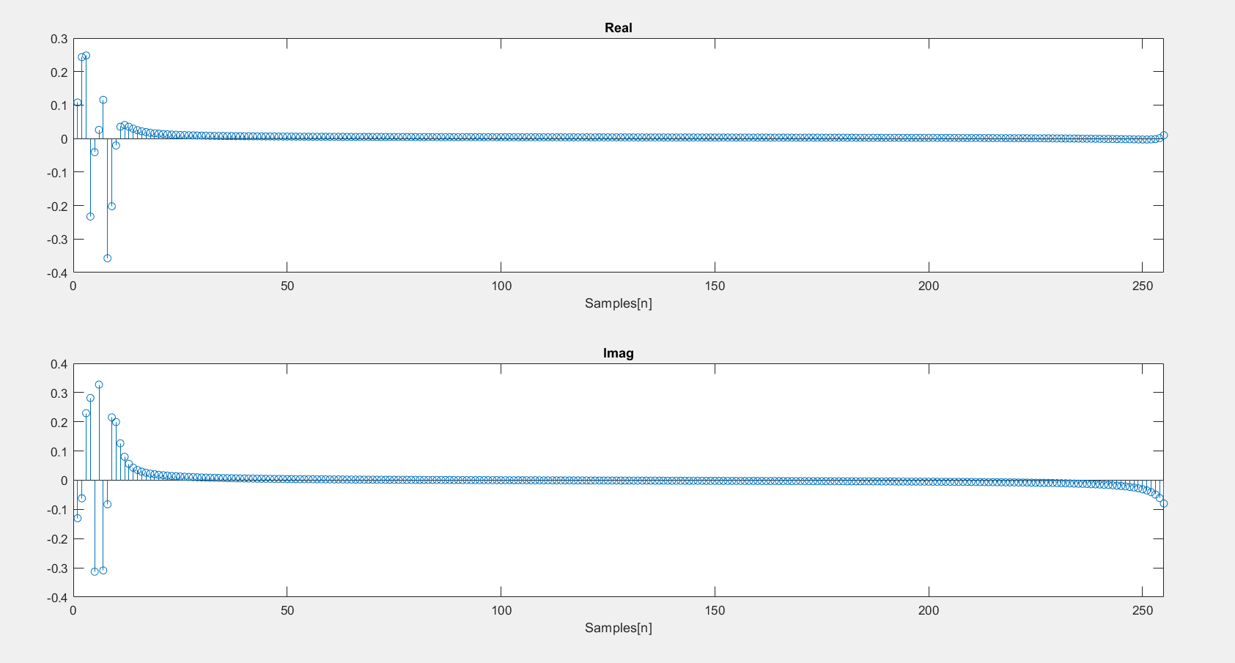
4. Number of Taps:

From